Replacement of Bucket-Wheel

Excavators at Mines Maritsa East EAD Project

Guide for Land Acquisition and Compensation

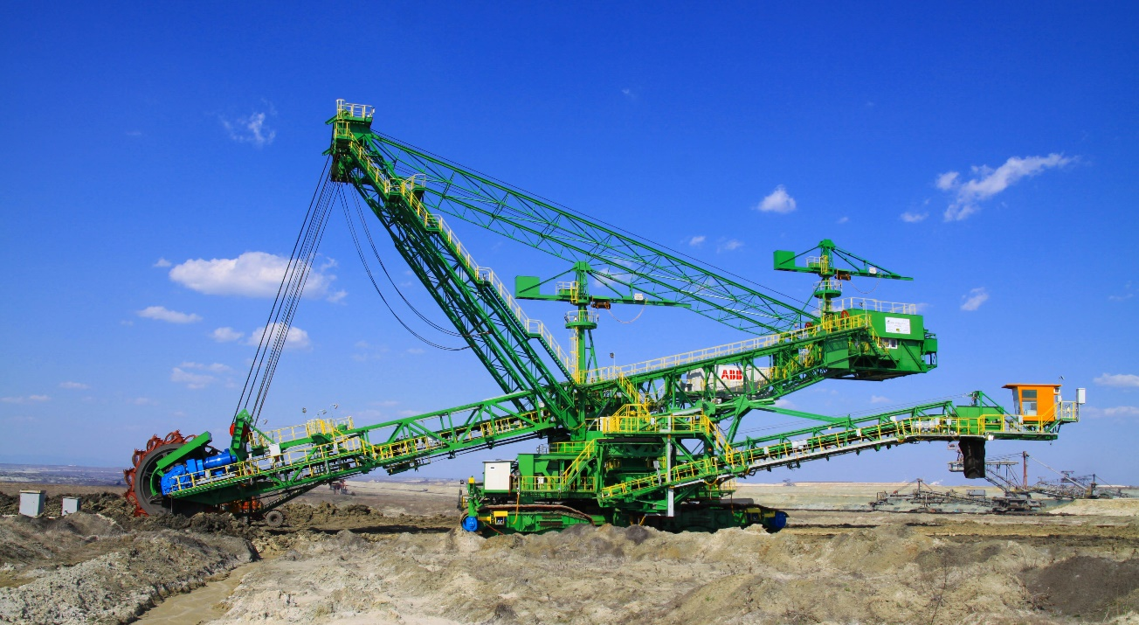

Acronyms
MME Mines Maritza East EAD
BEH Bulgaria Energy Holding
EBRD European Bank for Reconstruction and Development

The project
Following the closure and decommissioning of Units 1 - 4 of the Kozloduy Nuclear Power Plant in 2007, Mines Maritza East complex became the centre of energy production in the Republic of Bulgaria with power generation capacity of more than 3300 MW. The power generated within Maritza East Complex burning lignite excavated at Mines Maritza East EAD is equivalent to about 45% of the gross power production in Bulgaria. The generated electricity has relatively the lowest cost and high competitiveness, which outlines the
extremely important significance of the extraction from “Maritsa East” coalfield for the energy balance and energy independence of the country. Providing of continuous coal mining is an important public need, as the energy independence is directly linked to the protection of national interests and the stability of Bulgarian economy. The gradual progression of mining activities requires the purchase of the properties of the inhabitants of Beli bryag and Troyanovo by Mines Maritza East and resettlement of people living there. Resettlement cannot be avoided, that is why efforts are made to make sure that it is done on a negotiated basis.

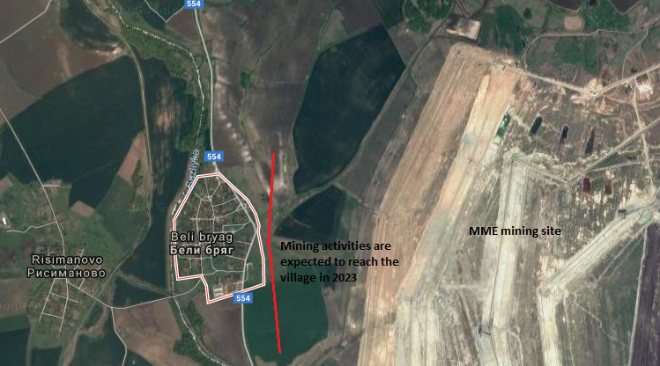

Years ago, resulting from geological studies, it was found that at relatively shallow depth under the village there were significant deposits of coal. This fact resulted in a decision made at governmental level that the village shall be resettled in order to expand the area of mining activities in defence of strategic state interests and ensuring the energy independence of the country.
The village of Beli bryag is situated in the area, often called the "energy heart" of Bulgaria. It is located on the territory of Stara Zagora District, Radnevo Municipality, in the very centre of the Maritza East Coalfield and near the border between “Troyanovo-1” and “Troyanovo-North” mines.

As a concessionaire for the extraction of the resources under Beli bryag village, Mines Maritsa East is responsible to undertake relevant actions in order to reach a negotiated agreement with land and property owners in the granted area. In 2017, MME had acquired about 65% of the total properties in the village of Beli bryag, both municipally and privately owned. Still remaining to be bought are 124 agricultural land plots and 71 land plots within the built-up area (regulated land area). Some of these plots have residential structures built on them and some do not. The resettlement process is expected to be completed by 2023, when the company estimates the mining works will reach the village.
Final government decision that the village will be resettled. MME awarded concession for 35 years
Socio-economic census in Beli Bryag
Mining works are expected to reach the village in 2023-2025

Detailed Site Development Plan is disclosed for Beli Bryag and Troyanovo. Public discussion
Expropriation process starts for PAPs who didn’t sell their properties

2005
2009
2011
2015
2017
2019
2023
MME has the first meeting with Beli Bryag residents. A regional socio-economic profile for Beli Bryag and Troyanova is ordered by MME management
Cut-off date announced in the local newspaper and notice placed at the Deputy Mayor's office after the completion of the census – 31 March
2020

Since physical and economic displacement cannot be avoided, the inhabitants of Beli Byrag village are considered to be in a situation of involuntary resettlement. That means that every person affected by the project is entitled to compensation, in one form or another.

- The legal provisions of the Republic of Bulgaria related to compensation in case of resettlement are fully respected by the company.

- MME is committed to respect the resettlement policy of the European Bank of Reconstruction and Development, which includes significant provisions about compensation and entitlements and will implement it for this project. You can find the full text of the policy on EBRD’s website (www.ebrd.com/news/publications/policies/environmental-and-social-policy-esp.html).

- Compensation based on full replacement value will be provided for land plots and buildings (Replacement value means that all costs associated with moving from current location to new location will be paid, including all deal-related costs such as transfer taxes and notary fees for buying a new property).

- The company will use the services of an independent licensed evaluator selected in accordance with the Procurement Law, to establish the market value of the properties on which the compensation is based.

- Owners can choose to receive cash compensation for their properties or compensation in kind on a “like for like” basis.

- The company has developed a detailed grievance mechanism which can be used by affected people should they have any concerns with the resettlement
Compensation Principles
The company will take all the necessary measures to make sure that no person is worse off than before the resettlement and that the livelihood and standard of living of the affected persons is improved or at least restored to prior levels.
All persons affected by the project will be provided with:
- free legal advice and assistance from the Legal Department of MME to ensure access to compensation;
- provision of transportation of their assets on a 100 km radius of Radnevo after the transaction is concluded.
- Flexible assistance provided by the Company: every household can request specific assistance packages according to their needs.

If you are:
Owner of a land plot with a residential structure, you can choose to receive cash compensation at full replacement cost OR an apartment from MME’s housing stock in Radnevo or Galabovo, plus cash compensation if the two properties are not of equal value. In addition, prior to the demolition, you are allowed to dismantle and take any materials from the sold property that you want and need. If you are not satisfied by the amount offered by MME for your property, you can wait for the expropriation process to begin in 2020. This means that you will receive cash compensation or you will have the right to appeal the amount in court.
The “like for like” compensation means that, instead of receiving cash compensation, you can choose to receive another land plot/residential structure of the same value as your former property, from MME’s stock of housing and land.
Owner of an agricultural land plot, you can choose between cash compensation at full replacement cost OR a land plot with equivalent surface and soil quality to the land reclaimed by the mine or belonging to the mine. You will be able to collect your crops from the sold agricultural plot until MME needs it for their own use, so there will be no compensation for crop loss.
Tenant / formal user of agricultural land or residential structure, you are entitled to be informed about the land or property acquisition at least 6 months in advance, to enable you to find another accommodation or land to lease. If you submit a Letter of Request to MME, the company is able to offer you housing or land for rent.

Informal tenant of residential structure or agricultural land, you will be informed about the acquisition of the house/structure/land at least six months in advance and you will be offered housing or land for rent from MME properties.
Member of the Agricultural Cooperative for Production and Services (ACPS), if any loss of crops occurs, you will receive cash compensation.
If the land that you sold to MME is not yet in front of the mining works, the ACPS can continue to process it and the respective rent, dividends and production will be received by you, the former owner of the property. In case the land that you sold to MME is directly in front of the mining works, the Company will pay you the value of the production for one year on the basis of documents proving such income from the previous year.
Vulnerable groups
Vulnerable groups refer to people who, by virtue of gender identity, ethnicity, age, disability, economic disadvantage or social status may be more adversely affected by project impacts than others and who may be limited in their ability to claim or take advantage of project benefits. Vulnerable individuals and/or groups may also include people living below the poverty line, the landless, the elderly, women and children headed households, refugees, internally displaced people, ethnic minorities, natural resource dependent communities or other displaced persons who may not be protected by national and/or international law (EBRD, Environmental and Social Policy, 2014).
Farmer who can prove income from agriculture, you will receive cash compensation at full replacement cost for loss of immovable assets, plus transport for any assets you wish to transport. Also, if you decide to sell your business, the company will evaluate it and provide cash compensation for business closure.

The company takes into account that there may be persons among the residents of Beli bryag who are in need of special assistance, thus, in addition to compensation, several measures are applicable to people who are more susceptible to resettlement impacts.
Meetings with each person in need of special assistance will be held by MME in order to better define the resettlement-related needs and the way of meeting those needs, coupled with free legal assistance from the company’s lawyers and provision of transport for the person’s relocation and his/her movable possession. Also, at request, the Company will extend the grace period for vulnerable persons by one additional year (i.e. 3 years), as well as reconsider the amount of rent payments if these persons are living as tenants in their former properties.

After the socio-economic census that took place in January-February 2016, several categories of people in need of special assistance were identified by the company among the residents of Beli bryag. These include individuals with low socio-economic status or unemployed, large households or households with children, persons with disabilities or suffering from chronic diseases and informal tenants of residential structures.
The company commits to ensure assistance for these categories in contacting governmental institutions such as social and health services, enrolling in qualification change courses or new schools for children, advising of trainings, qualification courses and job opportunities at MME or other forms of assistance decided after the individual meetings.

Price ranges

Based on actual calculations carried out in 2015, of residential buildings and their surrounding properties, taking account of condition and location, the average price per square metre for a property in the area nearby is approximately BGN 10. The full price of the property includes the value of the garden, the additional structures and perennial crops and trees, if any.
The price of agricultural land outside the built-up area of the village varies depending on the condition and category of the land. The maximum purchasing prices that the company was allowed to pay for agricultural land properties in 2015 are listed in the below table. Since they were higher than the market prices in 2015, these prices are still valid in 2017.

Agricultural land category | Maximum price per decare
III | BGN 1250
IV | BGN 1000
V | BGN 850
VI | BGN 600
VII | BGN 400
VIII | BGN 300
IX | BGN 200
X | BGN 150
Key points

- The resettlement of Beli bryag village is is required by government policy to enable a project of wider public interest
- every person affected by the project is entitled to some form of compensation
- no person should be worse off than prior to the resettlement
- special assistance is given to people if needed
- valuation of properties is performed by an independent licensed appraiser
- prices of properties vary depending on their condition, location, additional assets, category and overall market prices

What are the key steps of the resettlement/compensation process?
You will receive a letter from MME expressing their need to purchase your property, be it agricultural land plot or land plot in the regulated area, with or without residential structures.

Step 2
You are invited to provide the necessary documents for the preparation of the assessment in a period of one month: Document of ownership, certificate of inheritance (in case the property is inherited), layout of the property, certificate of tolerable construction (if necessary), authorization letters (if necessary), tax assessment, inventory of perennial plants (in case there are such within the property), identity card (of all owners). All the specific and/or additional documents that need to be provided will be listed in the notification letter.

MME will contact you in order to set a date and time for an individual meeting. During this meeting you can express your specific needs related to the resettlement, such as assistance in filling out documents, legal support, transportation needs, etc.
Step 1

Step 3
As soon as the documents are submitted, MME will use the services of Stroyproject TD to carry on the evaluation of the property (more information about Stroyproject TD can be found in the annex to this guide).
The price of the property is decided taking into consideration the sale of the construction materials and by comparing similar property for sale on the market and it will include the price for additional immovable structures and perennial crops and trees.

Step 4
Once the evaluation is completed, MME draws up a preliminary contract for buying the property and you and your family (or whoever you consider necessary) will be invited to see the evaluation report. A summary of the report will be given to you for your further consideration.

Step 5
If you simply cannot reach an agreement with the company regarding the price of your property, MME will start the expropriation process in 2020. This means that a motivated request will be submitted to the Ministry of Energy, the legal office that can undertake actions towards expropriation under the State Property Law, together with proof that the concessioner has offered to purchase your property at a price no lower than the valuation defined under the above mentioned order, and you have rejected it within a month, tacitly or explicitly.
Parties affected by expropriation can appeal to the Acts of the State Administration - before the Court – and possibly change the size of the compensation.

you can either agree with the offered price and receive cash compensation in three months (or in kind compensation), or refuse the price offered by MME and request another evaluation after six months. Another option is to hire a licensed evaluator to carry out a second evaluation for your property. If the difference between the two evaluations is significant, the case goes before The Ethics Committee of the Association of Independent Evaluators, who decides what needs to be done in that situation.
Step 6
If you purchase a new property within a year, the Company will reimburse your transactional expenses (e.g. notary fees). For this to happen, you have to send a request to MME, together with the proof of paying those costs. MME will fully cover the costs if the value of the newly acquired property does not exceed the value of the compensation received for the former property. If it exceeds the amount you received for your former property, the difference in transactional costs will then be supported by you.

If you, as an owner or project affected person, have requests, grievances, suggestions, reports or queries related to the resettlement or land acquisition process, you can submit them to MME through phone, fax, e-mail or hard copy.
CONTACT DETAILS FOR GRIEVANCES:
daniela zheleva
Tel: 0417 / 83305; 82575; extension – 3186
Mobile: 0888 222 934
Email: daniela.zheleva@marica-iztok.com
It is preferred that the grievance is signed by the person filling it rather than submitting it anonymously, to receive a response.

An employee from MME will take your case and make primary assessments within 3 days from the receipt date and then redirect the case to the Grievance Committee.

The Grievance Committee will check circumstances, suggest solutions and issue a Record containing findings and conclusions in 20 days from the receipt date of the grievance. In 5 days after this Record is issued, you should receive a written response from the company in which a motivated and grounded opinion will be given about each of the complaints risen. In case the grievance is found legitimate, immediate corrective measures will be taken by MME.

In case you are not satisfied with the response you received, you can lodge a grievance to the company’s Board of Directors. Send a copy of the original letter of grievance and a copy of the response received, attached to a letter of grievance addressed to the Board of Directors of “Mines Maritsa-east” EAD, Stara Zagora. The Board will consider the submitted letter of grievance at its meeting and will issue a written response.

If you disagree with the Committee’s response, a recourse mechanism can be applied. The order of recourse or appeal can either follow the hierarchical order of management of MME (i.e. Board of Directors, Bulgarian Energy Holding /BEH/, Ministry of Energy, Prime Minister), or it can be directed to the ombudsman, National Legal Aid Bureau, etc.

Frequently Asked Questions

Q: When will the mining works reach the village?
A: Analysing the prospects for the intensity of the progress of mining activity in Troyanovo-North mine during the coming years and depending on the workload of the thermal power plants – TPP “AES-Galabovo” in particular – the estimative time period in which the mining activities will reach the village is 2023-2025.

Q: Pursuant to the "like-for-like" principle, can housing with a garden be provided to those preferring this type of compensation?
A: As MME does not own such properties in settlements outside the mining area, if the owner prefers the compensation in kind, he/she will be offered a home from MME housing stock available, in order to comply with the "like-for-like" principle. In case of an interest expressed by an owner, there is a list of the properties owned by the Company available at MME, which will be presented to him/her to choose from, and a view and negotiation of details for the replacement will be arranged and carried out.

Q: Regarding compensation in kind, is housing property provided with a notary deed for ownership?
A: In case the owner wants to replace his present home with one from the housings owned by MME, the newly acquired property will be provided with a notary deed for ownership.

Q: Can I receive the evaluation report of MME’s selected appraiser prior to the day of negotiations?
A: The evaluation prepared by the evaluator is a MME document for which the Company has paid the respective price, the aim being to prepare a market price for the property purchase and sale. Following the approval of the evaluation by MME Board of Directors, the owner is given the evaluation report on the day of the negotiations to acquaint him/herself with the evaluation of his/her property made by the licensed evaluator.
The owner will not be allowed to take the evaluation report outside the Company's building, since the report is of confidential nature (with respect to third parties) and will be preserved as such during and after the procedure. By providing the evaluation report earlier, there is a risk of confidentiality violation and its disclosure to third parties (other than the buyer and the seller).
During the negotiations day, the owner can be accompanied by his/her family or whomever they consider necessary, they can take notes and can request time alone to discuss the offer. The owner will receive a summary of the evaluation report for his further consideration. The owner can sign the contract during that meeting if he/she agrees with the price, or, if a decision is not reached, can sign the Minutes of negotiations held and come back at a later date (within 6 months, which is the validity period of the evaluation).

Q: What is the time period between the submission of request for acquisition and property evaluation? How long does it take until the transaction is signed before a notary?
A: It takes 3 months from the moment MME sends a request of acquisition until the property evaluation is completed, another 3 months from the preparation of the evaluation until the preliminary contract is drawn and 3 more months until the transaction is signed before a notary.

Q: What are the methods of property evaluation?
A: To obtain the fair market value, at least two methods shall be used. The evaluation currently used by MME is based on two methods:
- the “real value” method and
- the “comparable sales” method.
These are two methods that are most favourable to the seller. The real value method is obtained by removing the changes that affect the average of the current prices in the economy (such as inflation). The comparable sales method considers the prices of similar properties in the settlements of the similar functional type in the region. This means that, a change in the prices of properties in the region results in a change in evaluations elaborated by the licensed evaluators.

Q: What does assistance with transportation mean?
A: MME will provide transport at a maximum distance of up to 100 km (in each direction) or within Stara Zagora District. For every resettled household the necessary freight vehicles will be provided to transport the movable property (household items) in accordance with the household’s needs, up to the complete relocation of the entire property. The way of implementation, the number of runs, the dates and the terms will be further agreed between the responsible person from the company and the respective household.

Q: What is the exact moment when owners can take the usable materials from their property?
A: The company does not specify the exact time for dismantling and taking materials because many people use the property for many years after it is sold to MME. Any usable materials from a property can be taken depending on the time and needs of the owners and the moment shall be determined by them. However, it has to be done before handing over the house back to the company.

Annex – Description of Stroyproekt TD, valuation company
The evaluation company is registered in Stara Zagora, 41 Ivan Shishman Street and is represented by Aleksandrov Ibanov and Gosho Genov Georgiev. The company has a licence (#2365 of 13.12.2003) for property evaluation, issued by the Agency for privatisation. It is also certified for property evaluation by Chamber of Independent Evaluators in Bulgaria (CIEB), (certificate # 900300014 of 14 December 2009).
Stroyproekt TD provides market evaluation for:
- Machines and equipment
- Immovable property
- Agrarian land
- Commercial entities
- Enterprises
- Liabilities
The company has been preparing evaluations for 25 years initially by virtue of documents issued by Ministry of Finance, and later by authorised state institutions, upon exams, organised by the Institute of free economy, Hamburg, Germany and American association of the evaluators.
Stroyproekt TD has provided market evaluations previously for:
- Privatisation of entrprises under the jurisdiction of Ministry of Energy:
- Еlectrification JsC, V. Turnovo,
- Еlectrification JsC, Shumen,
- Еlectrification JsC, Haskovo,
- Еlectrification Ltd, Kurdjali,
- Ministry of economy
- Commercial JsC, Stara Zagora
- Service station of Jiguli, Stara Zagora
- Banks for collateral evaluation
- Unicredit Bulbank
- Allianz bank
- Express bank
- Accounting, reevaluation of long term activities acc. IAS 16

Regulated land area is the Bulgarian term officially used to describe the built-up area.

